Ministry of Science and Higher Education of the Russian Federation
ITMO University

Faculty of Digital transformations Educational program Big data and machine learning
Subject area (major) Applied mathematics and informatics

REPORT
“Analytical review on evolution from early NLP techniques to state-of-the-art multimodal large language models to identify a research gap”

Student Syed Muhammad Shajee Raza, academic group J4132

Date 18.01.2025

List of executors: Master of Big Data and Machine Learning

Syed Muhammad Shajee Raza
(signature, date)

Contents

- Natural Language Processing 7
  - Classical NLP Tasks 7
    - Sentiment Analysis 8
    - Topic Modelling 9
    - POS Tagging 9
    - Named Entity Recognition (NER) 10
    - Tokenization 10
  - Modern NLP Tasks 11
    - Machine Translation 11
    - Question Answering 12
    - Text Summarization 12
    - Information Extraction 13
- Text Vectorization Techniques 14
  - One Hot Encoding and Bag of Words 14
  - Term Frequency-Inverse Document Frequency (TF-IDF) 15
  - Word Embeddings 15
    - Word to Vector (Word2Vec) 15
    - Global Vectors for Word Representation (GloVe) 16
    - FastText 16
    - Contextualized Representations (ELMo) 17
    - BERT Vectorization 17
    - Tokenization 18
- Language Modelling 19
  - Early attempts in Language Modelling 20
    - Statistical Language Models (SLMs) 21
    - Neural Language Models (NLMs) 21
  - Breakthrough with Transformer architecture 21
    - Attention Mechanism 22
    - Feedforward Networks 24
    - Positional Encodings 24
  - Bidirectional Encoder Representation from Transformers (BERT) 24
    - BERT Architecture 25
. 25
    - Pre-training BERT 25
  - Generative pre-trained transformer (GPT) 26
    - GPT’s Architecture 28
- Multimodal Large Language Models (MM-LLMs) 30
  - Multimodal Encoders 30
  - Input Modal Aligner 30
  - LLM Backbone and Output Modal Aligner 31
  - Comparison of MM-LLMs and LLMs 31
- Examples of SOTA open-source models 33
  - BERT in hugging face transformers 33
  - GPT in OpenAI’s Codebase and h2oGPT: 33
  - T5 (Text-to-Text Transfer Transformer) 33
  - CLIP (Contrastive Language-Image Pre-training) 34
  - LaMDA (Language Model for Dialogue Applications) 34
  - Applications in Real World Problems 35
- Gap Identification in the Knowledge Field 36
  - Limitations 36
  - Proposed research gap 37
  - Future Directions 38
- Conclusions 40
- Summary 41
- Bibliography 42

Introduction
Natural Language Processing (NLP) has come a long way from statistical models to today we have large language models (LLMs) that can understand and generate human-like language. When multimodal capabilities were incorporated (text + image + audio and video) it was game changer to work on the field as models can work on different data formats for massive applications. Multimodal LLMs (MM-LLMs) are a significant step, combining the capabilities of LLMs and vision models to solve real-world problems in fields like healthcare, education, and autonomous systems.
Pre-trained transformer models to provide foundations for modern NLP (hugging face transformers, BERT, GPT) have pushed transformer architectures, but further developments for multimodality are unfolding. Recent innovations, such as contextual embeddings and cross-modal alignment methods, have improved generalization, but challenges, such as computational inefficiencies, scalability, and ethical issues remain. This paper covers a detailed analytical view on the development of the NLP, the state-of-the-art MM-LLMs, and then identifies an important research gap keeping in mind the essentials to drive further advancements in the domain of Big Data and the Machine Learning.

Natural Language Processing
Natural Language Processing (NLP) is a fascinating and fast developing discipline that crosses computer science, artificial intelligence, and linguistics. With the use of natural language processing (NLP), computers are able to comprehend, interpret, and synthesise human language in a manner that is not only meaningful but also helpful. NLP focusses on the interaction between computers and human language. The ever-increasing amount of text data that is produced on a daily basis, ranging from research articles to social media posts, has made natural language processing (NLP) an indispensable instrument for the purpose of gathering valuable insights and automating a variety of operations [1].

Classical NLP Tasks

These classical NLP tasks form the foundation of computational linguistics. They focus on the understanding and processing of the human language. The are very important for machines to extract, analyze and use the linguistics patterns for various applications. Language is based on some components like syntax, semantics and the context. By using these components classical NLP tasks like named entity recognition (NER), parts of speech (POS) tagging, sentiment analysis, topic modelling and tokenization are performed, and they become the building blocks for modern language processing systems.
To perform NLP tasks, a series of data preprocessing steps are also applied. First one is to clean the noisy data. Noisy data is the one that is not adding to the context of the overall text. Numbers, conjunctions, punctuations or symbols that don’t make sense between the words are noise as well. Second this is the conversion of letters from uppercase to lowercase, all the words are converted to lowercase letters and the noise arising from the capitalization of the letter is removed. Numbers and punctuation marks are also considered noise in some

cases and are removed before training the model. Next step is to tokenize the data, it is the process of separating the sentences contained in the text data into the smallest unit. Every word becomes a single token. And then stemming and lemmatization are applied to find root words for the words present in the text. For example, the root word for words like driven, drives, drove is drive [1].

Sentiment Analysis

Sentiment analysis is a very central component of NLP. Its function is to identify and categorize sentiments present with in the text data, through which we can assess the emotional tones, opinions and attitudes.
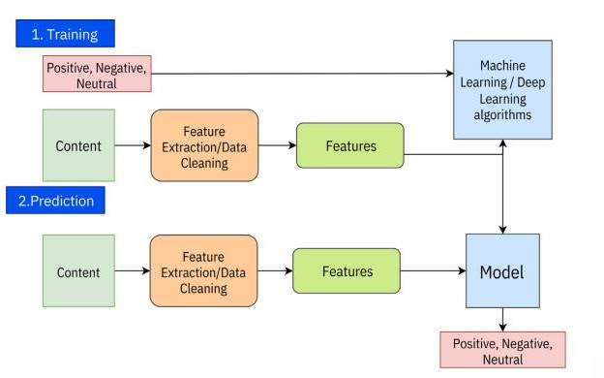

Fig. 1 – Working Process of sentiment analysis

Sentiment analysis is used in healthcare sector, financial markets, customer support, entertainment, education, e-commerce, social media and other sectors [2].

Topic Modelling

In NLP, topic modelling is a text mining technique that applies unsupervised learning to huge sets of texts in order to provide a summary set of terms that are obtained from those documents that represent the collection's overall principal set of themes.
Topic modelling is an unsupervised machine learning technique used in natural language processing (NLP) to discover hidden topics in a collection of documents. It consequently examines how often different words appear together and clusters similar words into topics. Text data is first represented as document- term matrix, in which each row represents a document, each column represents a unique word, and the entries of the document-term matrix indicate the frequency of words in the document. Algorithms like Latent Dirichlet Allocation (LDA) apply on this matrix and identify groups of words that appear together in the same context, these groups of words are then interpreted as topics. Then each document is considered as a mixture of these topics, with specific proportions, giving a better insight in what a document contains.

POS Tagging

In natural language processing (NLP), part-of-speech (POS) tagging is a method for giving words in a sentence grammatical labels or tags. These tags specify each word's function in the sentence, including whether it is a conjunction, noun, verb, adjective, adverb, or preposition. Numerous NLP applications, such as machine translation, information retrieval, and text categorisation, use POS tagging. For instance, POS tags are used to identify proper nouns in named entity recognition, which helps to identify named entities. POS tags aid in the identification of adjectives and adverbs, which in turn aids in sentiment analysis. POS tags help identify key sentence components in automatic

summarisation. POS tags aid in recognising sentence structure in language translation, facilitating precise translation. All things considered, POS tagging is an essential technique for natural language processing that improves the precision and effectiveness of a variety of language processing activities [3].
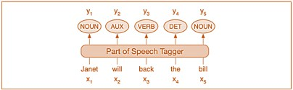

Fig. 2 – POS Tagging

Named Entity Recognition (NER)

As the name is self explanatory, NER is an essential task in NLP, which locates and categorizes named entities in structured text. These may include names of people, places, organizations, dates and more. This is essential for many NLP tasks. NER plays a key role in extracting structured information from the text, enabling machines to understand human language efficiently. It is used in sentiment analysis, information retrieval, QNA and knowledge graph construction [4].

Tokenization

Every NLP pipeline starts with tokenisation, which has a significant impact on the rest of the pipeline. A tokenizer converts unstructured data and natural language text into discrete information chunks that can be used as a vector representing the document. Tokenisation can separate sentences, words, characters, or sub words; to split the text into sentences, it is called sentence tokenisation, and to split the text into words, it is called word tokenisation.

Fig. 3 – Sentence Tokenization

Fig. 4 – Word Tokenization

Modern NLP Tasks

In modern NLP tasks, we use deep learning and transformer-based architectures to tackle complex language understanding and generation challenges. These tasks include machine translation, question answering, text summarization, information extraction etc. A transformation in the industries like education, healthcare, customer service etc has been seen due to these modern NLP techniques and state of the art models.

Machine Translation

Fundamentally, machine translation is the process of translating speech or text between languages using artificial intelligence. Historically, rule-based techniques were a major component of early translation systems, which frequently produced uncomfortable and linguistically inaccurate translations.
Now over the years, machine translation systems have evolved, from rule- based approach to a direct translation approach in which word to word translation is made using a bilingual dictionary. Then there is an interlingua approach in which source text is presented in an intermediary (semantic form) called interlingua, and then it is further translated to target text. And many other

approaches like transfer-based translation, statistical based approach, hybrid translation, knowledge-based translation and example-based translation [5].

Question Answering

In information retrieval, a Question Answering (QA) system uses either a pre-structured database or a collection of natural language texts to automatically respond correctly to queries posed by humans in natural language. By employing a knowledge base (documents) as background, Question Answering (QA) models can be used to automate the answers to frequently asked questions [6].
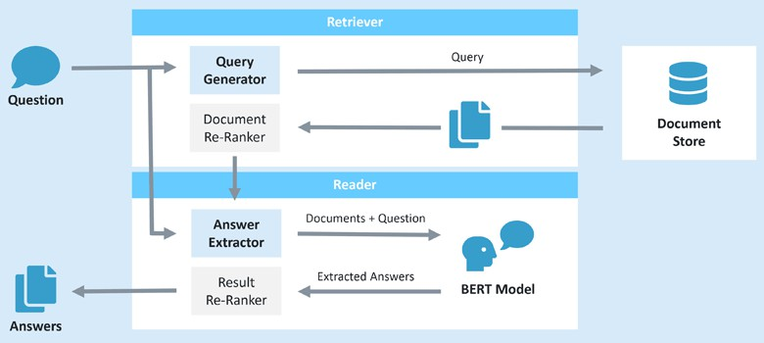

Fig. 5 – NLP based QA System

Text Summarization

To summarize text using NLP, identifying the most important sentences or phrases in a text document is the first step. The lines or phrases that are selected are typically picked because of their significance, how they fit together, and relevance to the context of original text. Selected phrases and keywords are included in the summarization. This divides the original text into sentences or words, which are chosen and rejected based on a relevance score. The final summary is based upon these chosen words and phrases [7].

Information Extraction

The goal of information extraction (IE), a key tool in NLP, is to automatically extract structured information from unstructured text. In order to convert enormous volumes of text into meaningful, well-organised information, this method entails locating and extracting particular data points, such as names, dates, relationships, and more.

Text Vectorization Techniques
These techniques are used to convert textual data into numerical formats that the machine can process. As we know that human readable data is not machine readable so this is a very important step to help the machine understand the data properly. In this technique relationships from text and meaningful patterns are extracted from the data and this is used in various NLP applications. Over the years, these techniques have evolved a lot, from obsolete techniques like one hot encoding and bag of words towards the advance text vectorization techniques.

One Hot Encoding and Bag of Words

Bag of words, is a very simple model. It counts the number of times each word appears in a sentence [8]. This gives the vector the same length as vocabulary. On the other hand, in one hot encoding, gives a matrix with 0s and 1s inside. 1 indicates that some text elements occur in the sentence. 0 indicates that the element is not present in the sentence.
But both of these methods are obsolete now because of the following reasons. Both these methods do not provide the contextual understanding of the text. They don’t capture the relationship between words. Then there is a dimensionality issue associated with these two methods. One hot encoding creates vectors with a dimension equal to the vocabulary size and so does the bag of words. So, they require high memories and it is very in efficient in case of large datasets. None of them capture any kind of semantic relationship thus they are unable to handle polysemy and synonymy. And due to their high memory requirement, scalability issues often occur in case of large datasets. Due to these reasons these methods are obsolete now.

Term Frequency-Inverse Document Frequency (TF-IDF)

It can be defined as the calculation of how relevant a word in a series or corpus is to a text. The product of term frequency (TF) and inverse document frequency (IDF) is known as term frequency-inverse document frequency (TF- IDF). It calculates the document's word relevance in relation to the entire collection of documents. It is calculated by the following formula [9].

The meaning increases proportionally to the number of times in the text a word appears but is compensated by the word frequency in the corpus (data-set).

Word Embeddings

Word embeddings are frequently examined using a variety of algorithms, including Word2Vec, GloVe, and FastText, each of which uses a unique way for collecting semantic relationships in a corpus. A word embedding is a representation of a word used in text analysis that typically takes the form of a vector, which encodes the word's meaning in such a way that words closer in the vector space are expected to be similar in meaning. It can approximate meaning and represent a word in a lower dimensional space. A word embedding is defined as a numeric vector input that permits words with similar meanings to have the same representation.
    - Word to Vector (Word2Vec)

Word2Vec is a technique that captures the meaning, semantic similarity, and relationship of words to surrounding text by converting them to vectors. This technique aids computers in understanding the meaning and context of words and keywords found in corpus.

The Word2vec method is based on a predictive strategy that can be applied with the continuous bag-of-words (CBOW) and skip-gram (SG) models. Continuous Bag-of-Words (CBOW) and Skip-Gram (SG) models use small neural networks to associate words with certain locations in a vector space [10].

Global Vectors for Word Representation (GloVe)

Instead of employing a word calculation job, the GloVe model effectively understands word embeddings by using a word co-occurrence matrix. A VXV square matrix, where V is the size of the vocabulary, is a co-occurrence matrix. Each matrix element shows how frequently the designated vocabulary objects occur within a predefined context frame that covers the entire corpus. The ability of GloVe to understand vector embeddings makes it easier to reduce literal errors when processing the co-occurrence statistics that the model requires.
It also takes into account the preparation corpus's worldwide co-occurrence statistics. The model has several hyperparameters that need to be carefully selected, including the size of the perspective window and the vector embedding's dimension. The word vectors produced by the GloVe approach and those acquired by word2vec are conceptually equivalent. However, unlike word2vec's predictive model, GloVe uses a count-based model as its basis [10].

FastText

The FastText model adds a particular constraint to the word2vec and GloVe algorithms. By using the word2vec skip-gram (SG) model, which incorporates inner sub word data in character n-grams, which represent sequences of adjacent characters, this model can leverage innovative, out-of-vocabulary (OOV) expressions. With this method, a word's vector representation is created by taking into account the combination of its sub word parts. This method also

makes it easier to create vectors for words that were not previously predicted and allows the model to capture the linguistic and structural ties between words [10].

Contextualized Representations (ELMo)

ELMo, also known as ELMo embedding, is a deep contextualised word in vectors or embeddings. In a number of NLP tasks, these word embeddings help achieve state-of-the-art (SOTA) results.
On top of a two-layer bidirectional language model (biLM), ELMo word vectors are calculated. Two layers are superimposed in this biLM model. There are two passes in each layer: forward and backward. The biLM catches the inner structure of the word because its input is calculated from characters rather than words. For instance, without even examining the context in which terms like "beautiful" and "beauty" occur, the biLM will be able to determine that they are linked on some level [11].
The ELMo vector that is assigned to a token or word is actually a function of the complete sentence that contains that word, in contrast with traditional word embeddings like word2vec and GLoVe. As a result, a word may have many word vectors depending on the context.

BERT Vectorization

BERT (Bi-directional encoder representation from transformers) is a commonly used SOTA deep learning model used for various NLP tasks. It is based on a transformer architecture. Transformers are very efficient in capturing long-range dependencies in text. BERT has bidirectionality feature that enables processing of text in both directions. Thus, the context of each word is effectively analysed. Based on the words that surround it in a sentence, the BERT model is

able to capture each word's contextual meaning. Thus, contextual word embeddings can be produced via BERT better than the traditional methods [12].

Tokenization

Language models are often composed of a “tokenizer”, which encodes a sequence of characters into a sequence of token ids, which map to substrings. The subsequent language modeling task is carried out by a neural network or transformer, which is pre-trained and fine-tuned on large datasets. The ideal goal is to jointly train the tokenizer and transformer with end-to-end accuracy as the objective [13].
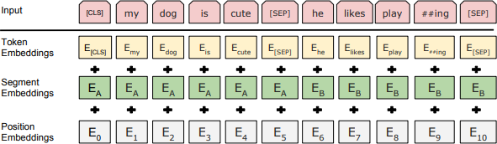

Fig.6 - Tokenization process and preparation of embeddings for BERT

In easier words, tokenization is the process of breaking the text down in smaller pieces. These pieces are called tokens. These tokens are understandable by machine learning models. This task is done in a few steps. Let’s move forward with an example. Imagine we have a sentence “My dog is cute”. This sentence is broken down into tokens as such: [“My”, “dog”, “is”, “cute”]. Then special tokens are added in such a way: [“[CLS]”, “My”, “dog”, “is”, “cute”, “[SEP]”]. [CLS] token is added at the start of text to represent the whole input and [SEP] to mark the end of sentence. Then these tokens are converted to numbers based on a predefined dictionary. So, after this, this sentence will become something like this. [101, 2026, 3899, 2003, 10140, 102]. And to ensure that all the inputs are of the same length, padding is applied.

Language Modelling
In NLP, language modelling is a technique that involves predicting the next word in a sentence or a sequence of words based on the context and previous words. Language modelling has evolved significantly over the years, from simple statistical models to complex deep learning architectures. In this section we will be discussing this evolution of language modelling. Given below is a timeline of developments in language modelling.
From traditional Large Language Models (LLMs) we have evolved to Multimodal Large Language Models (MLLMs). This has been done by integrating multiple modalities such as text, images, audios and videos into LLMs. This enhances the Models ability to understand and generate content across different formats [14].
The key breakthrough in this field was brought by Word2Vec [15]. In word embeddings the idea was to map words into continuous vector spaces based on their occurrence in the text. By this the machines were able to capture semantic similarity. After this breakthrough came GloVe [16]. What GloVe did was to combine word co-occurrence statistics with embeddings. By doing this a higher interpretability and performance on downstream tasks was achieved. After these major developments came the Contextualized Representations Era, 2017-2018. In 2018, Embeddings from Language Models (ELMo) introduced contextualized word embeddings. Word2Vec created dynamic embeddings sensitive to context by using long-short term memories (LSTMs). Then came the transformer models that are still being used, what they did was that, they eliminated the use of LSTMs by introducing attention mechanism. Transformers laid the foundation for all modern LLMs [17]. After the contextualized representations era came the pre- trained transformer models era. BERT, developed by google, introduced masked language modeling and next sentence prediction. By fine-tuning BERT many

NLP tasks could be done [18]. After BERT, OpenAI’s GPT focused on unidirectional language modelling, and using a transformer decoder for text generation. It was followed by GPT-2, which showcased a significant improvement in text generation [19]. By scaling the model size and training data, OpenAI launched GPT-3 with 175 billion parameters. It performed few-shot and zero-shot learning effectively. After that GPT 3.5 came and later GPT-4, ChatGPT incorporated fine-tuning and reinforcement learning with human feedback. That’s why it excels in conversational tasks. Models Like GPT-4 and PaLM paved the way towards multimodal tasks which includes the incorporation of images, texts, videos and audios for domain specific applications.

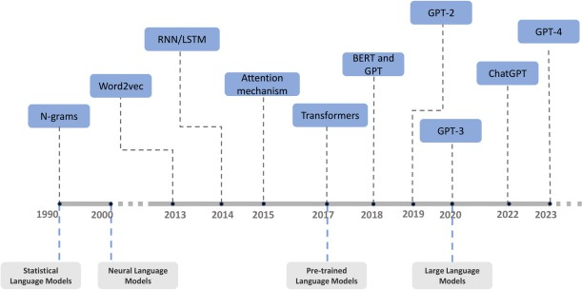

Fig. 7 – History and development of LMs

Early attempts in Language Modelling

Some of the early attempts in language modelling are discussed in this section as this is important to analyse the developmental dynamics and influences shaping language modelling.

Statistical Language Models (SLMs):

SLMs were found in the 1990s. They were mathematical models that addressed contextually relevant properties of natural language from a probabilistic statistical perspective. Determining the probability that a sentence will appear in a text is the fundamental task of statistical language modelling.

Neural Language Models (NLMs):

Neural networks are used by NLMs to predict the likelihood of succeeding words in sequences. They reduce the restrictions related to small n in SLMs and efficiently handle longer sequences [20].

Breakthrough with Transformer architecture

Transformers are language models that were introduced in 2017. Few famous examples of transformer models are GPT, BERT, BART, T5 etc. Unlike the previous models with sequence transduction, the transformer model has an encoder – decoder structure. The transformers have a multi-head attention mechanism proposed in addition to the point-wise feed forward network. The figure below shows an overall architecture of a transformer model.

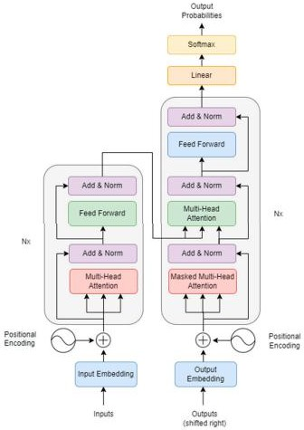

Fig. 8 – Transformer Architecture

Let’s break down this architecture and discuss the components of transformers in detail.

Attention Mechanism

This is the most important component of a transformer. This allows the model to learn the relationships between the elements of a sequence. In the context of an LLM like BERT, this would imply that the model would utilise self- attention to determine that the "bank" in this sentence refers to the side of a river rather than a financial institution in the line "The bank of the river is overflowing." [21]

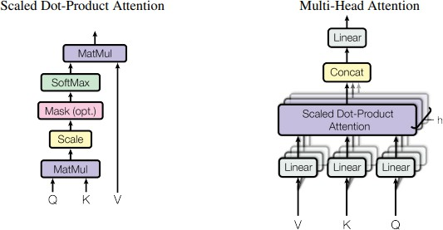

Fig. 9 – Different types of attention mechanism

An attention function can be defined as mapping a set of key-value pairs and a query to an output, where the query, keys, values, and output are all vectors. The output is calculated as a weighted sum of the values, with each value's weight chosen based on a compatibility function between the query and the corresponding key.
The transformer model uses multi-head attention in three different ways.
      - The queries in "encoder-decoder attention" layers originate from the previous decoder layer, while the encoder's output provides the memory keys and values. This enables all points in the input sequence to be attended over by every position in the decoder. In sequence-to-sequence models, this resembles the usual encoder- decoder attention methods.
      - Self-attention layers are present in the encoder. Every key, value, and query in a self-attention layer originates from the same location, which is the encoder's output from the previous layer. Every point in the encoder can address every position in the encoder's preceding layer.
      - In a similar manner, the decoder's self-attention layers enable any position to attend to every other position up to and including that position. To maintain the auto-regressive characteristic, we must stop the decoder's information from flowing leftward [17].

Feedforward Networks

The feedforward network, which comes after the self-attention layers in the encoder and decoder, is another crucial part of how transformers work. This network applies a non-linear ReLU activation function and two linear transformations to every point in an identical and independent manner. As a result, the token is processed independently, enabling the model to guarantee the same treatment across all input positions. This enables the model to understand the intricate data transformations at every location [21].

Positional Encodings

Because the transformer's self-attention mechanism treats all inputs simultaneously and identically rather than sequentially like RNNs or LSTMs do, it indicates that the self-attention layer is unable to take sentence structure into consideration. But because the words are sequential, a method that preserves the word positions inside the encoded data is required. For this reason, the transformer model uses position encodings that are appended to the input embedding [21].

Bidirectional Encoder Representation from Transformers (BERT)
BERT, which stands for Bidirectional Encoder Representations from Transformers, is a natural language processing machine learning (ML) model. It was created in 2018 by Google AI Language researchers and functions as a universal solution for more than eleven of the most prevalent language tasks, including named entity recognition and sentiment analysis.
BERT uses both left and right context conditioning in every layer to pretrain deep bidirectional representations from unlabelled text. To achieve state-

of-the-art models for a variety of tasks, including question answering and language inference, the pre-trained BERT model can be optimised with just one more output layer without requiring significant task-specific architecture changes [12].

BERT Architecture
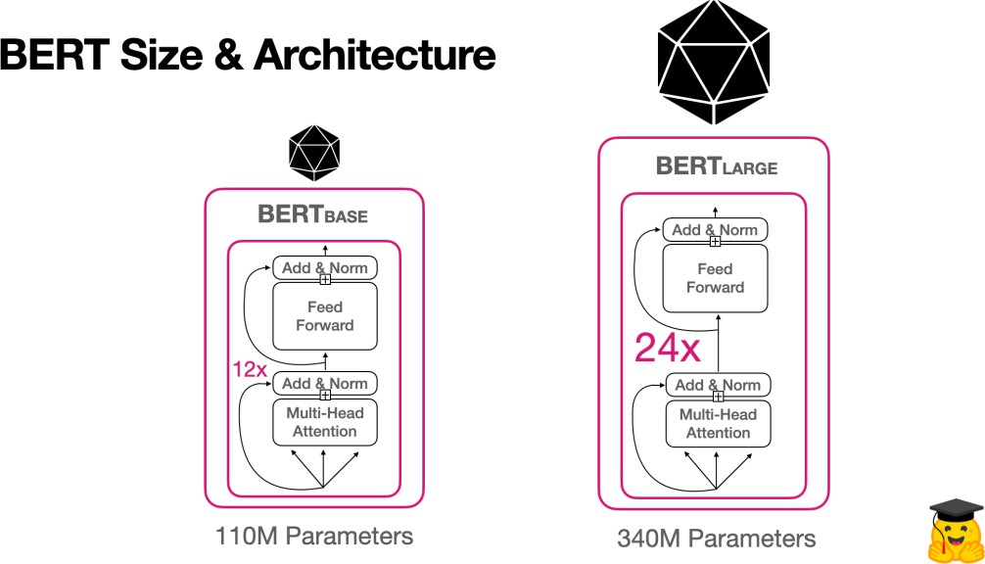

Fig. 10 – BERT Size & Architecture

Based on the architecture BERT has two variants. BERT base (110 parameters) and BERT large (340M Parameters). BERT base has 12 layers of transformer blocks on the other hand BERT large has 24 layers of transformer blocks. Each transformer block consists of a multi-head attention which allows the model to focus on different parts of input sequences simultaneously. They also consist of a feed forward network that processes the output. Then there are add and normalization layer, to stabilize and improve training.

Pre-training BERT

BERT is pre trained using two unsupervised tasks called masked language model and next sentence prediction.

      - Masked Language Model: In order to pre train BERT, some percentages of the inputs are masked and then these masked inputs are predicted by the model.
      - Next sentence prediction: In order for the model to understand the relationship between two sentences this process in applied. In a training example 50% of the times the text is actually the next sentence and 50% its not, for the model to understand the relationship between sentences [12].

Generative pre-trained transformer (GPT)

GPT is a deep learning model that has been pre-trained on large text data corpora. It can be adjusted for particular applications such as text classification, sentiment analysis, language modelling, machine translation, and language synthesis. Compared to earlier NLP techniques like RNN and CNN, the transformer architecture employed in GPT represents a substantial improvement. Its self-attention mechanism enhances the model's comprehension and generation of language by enabling it to take into account the context of the full sentence when generating the next word. The output text is produced by the decoder using the input representation as a guide [22].
The first Generative Pre-trained Transformer (GPT) model was released by OpenAI in 2018, marking the start of the adventure. Using 117 million parameters, GPT-1 was a breakthrough in natural language processing (NLP) that produced writing that resembled that of a human depending on the context.
The journey from GPT1 to GPT4 is a huge progress in the field of natural language processing. GPT1 laid the foundation but it was limited in its capacity and complexity. GPT2 scaled up to 1.5 billion parameters, improving the versatility and coherence in tasks such as summarization and translations. But in

GPT2 there were some kinds of ethical concerns associated with it due to the possibility of misuse and it was also very resource intensive. GPT3 marked a major leap with 175 billion parameters, which made it perform even better in natural language understanding, but this increased the resource demands even more. Another limitation of GPT3 was that sometime inconsistencies were seen. It often generated contextually incorrect or irrelevant responses. GPT4 solved this issue with enhanced accuracy, efficiency and contextual understanding. The most recent evolution, GPT-4o, excels at programming help, creative writing, and producing organized outputs. It overcomes previous issues and proves to be a strong, dependable instrument for academic and professional applications.

Feature | GPT | BERT
Core Architecture | Autoregressive,  generative | Bidirectional, Context  based
Training Approach | Predicts the next word in sequence | Uses masked language  modelling to predict words from context
Direction of context | Forward | Bidirectional
Primary usage | Text generation | Text analysis and  understanding
Generative capabilities | Yes | No
Output | Generates new text sequences | Provides contextual  embeddings for various NLP tasks
Table 1 – Comparison of GPT and BERT

Key take away from this table is that the choice between GPT and BERT depends on the specific requirements of the applications. For example, GPT

excels in tasks that require text generation. Its autoregressive characteristic makes it perfect for situations where the production of coherent and contextually appropriate text is vital. And BERT is superior for tasks that require understanding of the context of language. This makes it suitable for tasks like NER, QNA and language understanding.

GPT’s Architecture

Neural networks power GPT models for NLP applications like language modelling, text categorisation, and text synthesis. GPT architecture is transformer-based. The Transformer model effectively handles variable-length input sequences using self-attention mechanisms for NLP tasks. To simplify the design, GPT replaces encoder-decoder units with decoder blocks. With GPT, the transformer model is pre-trained on enormous volumes of text input using unsupervised learning approaches. During pre-training, language modelling includes predicting the next word in a sequence based on the preceding ones. Through pre-training, the model learns natural language representations that may be tailored to specific tasks.
Following are the components of GPT’s architecture.

      - Input embedding layer: Converts inputs tokens into numerical vectors.
      - Positional encoding: Used to add information regarding the positions of each token in a sequence.
      - Masking: During training, some tokens are masked, and the model predicts them to learn the relationship between words.
      - Transformer blocks: This is the core of GPT. Attention mechanism is used in these blocks to focus on different parts of input.

      - Linear and softmax functions: Softmax is used to produce probabilities i.e input belongs to a specific category or not. Linear functions calculate the “query”, “key” and “value” vectors for attention and sends the outputs in feed forward layers [22].
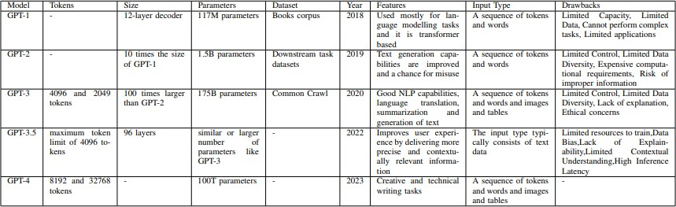

Fig. 11 – Comparison of different versions of GPT model
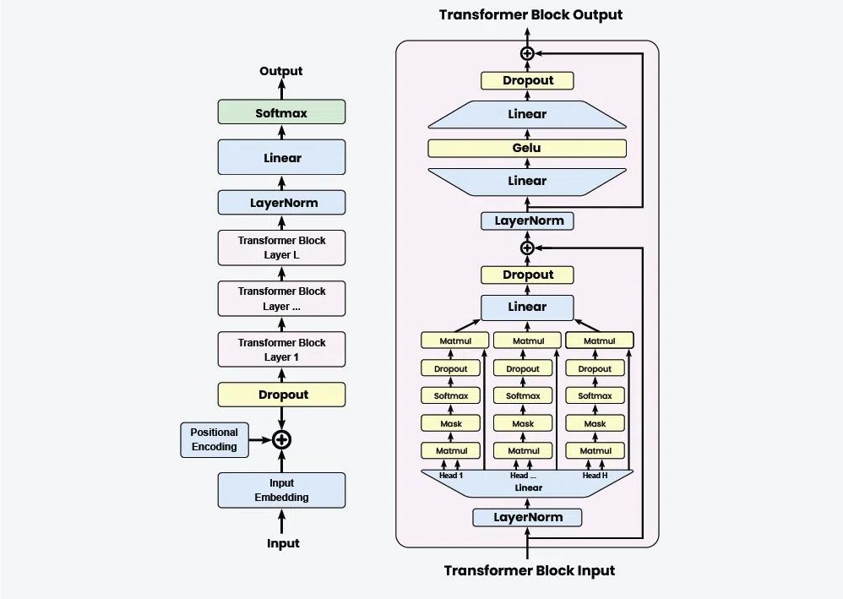

Fig. 12 – GPT Architecture

Multimodal Large Language Models (MM-LLMs)
MM-LLMs uses the strengths of LLMs and vision models to perform complex tasks that are based on different data types. Examples of this can be generating stories using images, generating images using text inputs etc.

Multimodal Encoders

The purpose of multimodal encoders is to extract features from several input modalities, including text, pictures, audio, and video. To take use of their feature extraction capabilities, pretrained encoders are usually used in the context of MM-LLMs with their parameters fixed. Image encoders like MAE, ViT, Swin Transformers, CLIP ViT, OpenCLIP are used. These image encoders are also repurposed to be used as video encoders by applying down sampling to retain a subset of representative frames. Then the process as same as it is for static images. Some commonly used audio encoders are CLAP, C-Former, Whisper and HuBERT.
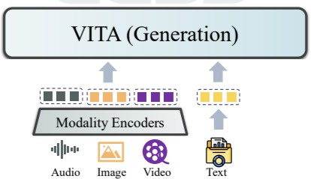

Fig. 13 – MultiModal Encoder in VITA MM-LLM

Input Modal Aligner

The purpose of the input modal aligner is to align feature vectors from various modalities—extracted by the multimodal encoder—to a text feature space

before converting them into feature representations that are compatible with LLM. Some notable input modal aligners are MLP, Q-Former, P-Former, MQ- Former, Linear Mapper etc.

LLM Backbone and Output Modal Aligner

LMMs use pretrained or finetuned LLMs for their working. This is what the LMM architecture is based on. Aligned multimodal inputs are sent to the LLM, which uses its comprehension, reasoning, and generating skills in textual feature space to produce text outputs or instruction tokens. These instruction tokens direct other components towards the completion of more complex cross- modal activities and respond to user-provided instructions.
The output modal aligner converts the instruction tokens generated by the upstream LLM backbone into feature representations that can be decoded into the target non-linguistic modalities, as opposed to the input modal aligner. Some commonly used output modal aligners are Linear Aligner, MLP and encoder- decoder transformers. [23]
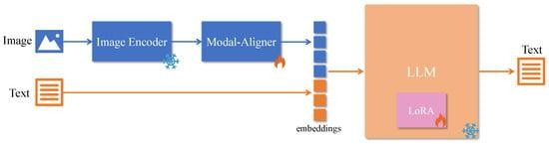

Fig. 14 – Architecture of IMG + Txt to Txt Model

Comparison of MM-LLMs and LLMs

In terms of architectural components, traditional LLMs primarily focus on text-based architecture such as BERT, GPT and PaLM series, which excel in natural language understanding and generation while MLLMs extend these

architectures by incorporating additional modalities like vision, audio and physiological data. When it comes to training strategies traditional LLMs involve large scale text corpora, leveraging techniques like masked modelling and next word prediction. Training of MLLMs involve multimodal datasets, strategies to align and integrate different data types. Techniques such as cross modal pretraining and joint embedding learning are commonly used. LLMs show a high performance in text-based benchmarks like GLUE and SuperGLUE while MLLMs show promising results in multimodal benchmarks but face challenges in achieving consistent performance across all modalities. [14]

Examples of SOTA open-source models
Given below are the few examples of state-of-the-art open-source models that use LLMs and MM-LLMs (like BERT and GPT) in systems.

BERT in hugging face transformers:

Hugging face open-source library provides pre-trained BERT models that can be fine-tuned for various NLP tasks. It is used for tasks like text classification, NER and QNA etc. An example of this application is given below.
https://huggingface.co/docs/transformers/en/model_doc/bert

GPT in OpenAI’s Codebase and h2oGPT:

H2o GPT is a library designed to support open-source LLM research and integration while preserving transparency and privacy. The majority of integrated models are made for both manufacturing and research. This library's primary application is the efficient deployment and testing of a broad range of LLMs on confidential databases and documents. With this tool, users can compare many models on multiple tasks and datasets at once [24].
An example of this application is https://gpt.h2o.ai/.

T5 (Text-to-Text Transfer Transformer):

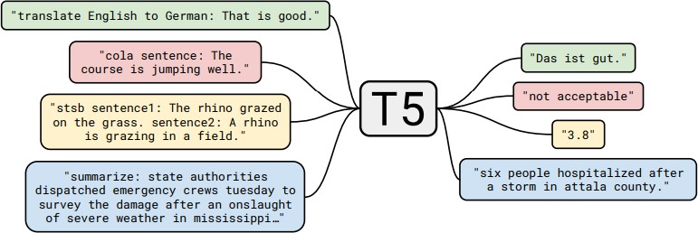

Fig. 15 – Diagram of Text-to-Text Framework.

The basic idea of this work is that all text problems are viewed as text-to-text problems, i.e., taking text as input and producing text as output. This approach is based on earlier unifying frameworks for NLP tasks, which enable us to immediately apply the same model, objective, training approach, and decoding process to every task we evaluate. Performance is tested on a wide range of English-based NLP problems, such as document summarisation, question answering, and sentiment categorisation, to name a few. With this unified approach, a comparison the efficacy of various transfer learning objectives, unlabelled data sets, and other parameters, while probing the limitations of transfer learning for NLP by scaling up models and data sets beyond what has been previously addressed [25].
An example of this application is https://github.com/google-research/text- to-text-transfer-transformer.

CLIP (Contrastive Language-Image Pre-training):

Recently, CLIP has been widely adopted as the visual backbone of multimodal large language models to connect image inputs for language interactions. The success of CLIP as a vision-language foundation model depends on aligning web-crawled noisy text annotations at image layers. Contrastive Language-Image Pre-training (CLIP) has been an observed technique for training vision encoders to generate image/text representations which aid many applications [26].

LaMDA (Language Model for Dialogue Applications):

LaMDA, a family of Transformer-based neural language models built for dialog. These models’ sizes range from 2B to 137B parameters, and they are pre- trained on a dataset of 1.56T words from public dialog data and other public online articles. LaMDA makes use of a single model to perform multiple tasks: it

creates probable responses, which are then screened for safety, anchored on an external knowledge source, and re-ranked to obtain the highest-quality response. [27]

Applications in Real World Problems

MM-LLMs are widely used in real world applications as well. Few examples are given blow.
- Virtual Assistants
- Creative industries and content generation
- Education and training
- Healthcare and diagnostics
- Autonomous systems

Gap Identification in the Knowledge Field
To identify a gap present in this knowledge field for my scientific research I will first share some limitations associated with multi modal large language models.

Limitations:

MM-LLMs have made a significant progress in integrating text, image and other modalities but they still are a work in progress. A key limitation associated with MM-LLMs is the alignment of different modalities. To make the model work effectively it is very important to coordinate the modalities very precisely, but often problems arise due to the lack of standardized datasets that can correctly represent the interaction between images, audios, texts and other forms of data. The problem is that the data is not scarce, and in some areas, they are not well presented in the training data, because of which the model struggles. This makes it hard for the MM-LLMs to work in real life situations. This causes a reduction in overall effectiveness.
Another significant limitation is the computational complexity associated with processing and integrating data that spreads over different modalities. Because of this MM-LLMs require a lot of computational resources for training, storage and inference. This is a great barrier in the way of researchers and organizations that have limited resources. This also causes the scalability issues to arise as the model grows in size and complexity, which affects their adaptability to evolving real-world applications. These high requirements of resources can even lead to environmental concerns due to the carbon footprint of training such large models.
In case of MM-LLMs the lack of interpretability is also a major obstacle. Understanding how these models process and combine data from different

modalities is still some kind of a black box to the world, which makes it difficult to trust their outputs in applications where the stakes are high. For example, healthcare or autonomous systems. Due to this it is complicated to debug them or improve them. Furthermore, there are also bias and fairness issues associated with multimodal settings. Some kinds of societal biases are seen in the training data, which can lead to discriminatory outputs spanning across different modalities, which compounds the risk associated with biased decision-making.
Another limitation is that the evaluation metrics for MM-LLMs are still underdeveloped. For LLMs we can see that some established benchmarks exist, but in the case where different modalities are involved, we see a lack in standardized metrics to assess the performance of the model over all modalities. Due to the existence of this gap, it is very hard to objectively compare models and look for areas for improvement. To address these issues what needs to be done is firstly an advancement in dataset creation, computational optimization, proper ethical considerations and the development of standardized and robust evaluation metrics so that the responsible deployment of MM-LLMs can be assured [28].

Proposed research gap:

With current MM-LLMs there is a problem of misalignment between different modalities like image, text and video. This problem leads to several inefficiencies and reduced accuracy in tasks. Because of this problem there is a research question that arises.
“How can these alignments be enhanced so that the accuracy and coherence of MM-LLMs can be increased?”

Future Directions

The future of MM-LLMs hold a very promising future, with a several areas that require advancements. One of the major requirements for this technology is the development of lightweight and efficient architectures that can overcome the current issues related to the complexity and scalability of MM-LLMs. Additionally enhancing data diversity and representation is critical. There is a need to build dataset that represent the real-world 8 multimodal interactions properly. Some must have properties that these datasets should reflect are inclusivity and minimum biases so that the MM-LLMs are generalized and able to perform equitably across different demographic and cultural contexts.
Advances in adaptive techniques of integrating data from different modalities is required to revolutionize the MM-LLMs processes. These integration techniques need to be dynamic and should be able to consider context specific importance of each modality. This can significantly improve the model’s performance in tasks that require nuanced understanding such as video comprehension and providing reasoning across different modalities. Furthermore, real-time multimodal data processing has to become a major focus, especially in applications like autonomous systems. Healthcare and smart environments where the model’s decision making is very critical.
As we discussed in the limitations above, the working of these multimodal models is like a Blackbox to the users. There is a need to develop interpretable and explainable AI for MM-LLMs. Such methods that can visualize and help understand how the model integrates and prioritize information across different modalities can create a trust and adoption in sensitive domains like legal and medical fields. Moreover, ethical considerations will play a great role in shaping the future of MM-LLMs. Researches are likely to put some focus on frameworks

that eliminate the bias factor, preserve the privacy of the users and responsible deployment of these models, ensuring their alignment with social values.
Expansion into the emerging modalities like haptic feedback, olfactory data and brain-computer interfaces also seem like very promising and exciting opportunity. By expanding into this field, the MM-LLMs would be able to cater to applications ranging from virtual reality experiences to advance medical diagnostics. By addressing these directions, future MM-LLMs can become more robust, versatile and human aligned systems being able to derive innovation across diverse fields and transforming the human-computer interactions [23].

Conclusions
Multimodal large language models are a very pivotal advancement in the field of artificial intelligence, that bridge the gap between different data types. From the root text based large language models to today’s versatile multimodal large language models, they showcase a great potential across different industries such as healthcare, education and creative industries. What MM-LLMs have achieved so far is something that should be praised but they still are a work in progress and they face several challenges. These challenges include computational inefficiency, lack of interpretability and some ethical concerns like fairness and biasness. To address these challenges there is a need for innovative approaches in architecture design, standardized and diverse data across different modalities and their alignment with societal values.
MM-LLMs hold a very bright future, with some very great directions like lightweight architectures, explainable AI, and expansion into the emerging modalities like brain-computer interfaces. As we see these models evolve and get better, we will see that they become more and more integrated into our daily lives as the time passes, by enhancing human-computer interactions and solving real- world problems. This review underscores the transformative potential of MM- LLMs and the critical need for responsible development to unlock their full capabilities.

Summary
This report presents an overview of the current state of Natural Language Processing (NLP), discussing the transition from classical methods to multimodal large language models (MM-LLMs). It explores significant milestones such as transformer-based models such as BERT and GPT which brought powerful contextual understanding and generative abilities. The integration of multimodal inputs, including text, images, and audio, has further extended their use in sectors such as healthcare, education, and creative industries.
While acknowledging the progress made, the paper underscores ongoing barriers including modality misalignment, computational inefficiencies, scalability concerns, and ethical issues like bias and fairness. A major research challenge related to improving modality alignment to optimize performance and coherence is identified. Future directions outline lightweight architectures, real-time processing, and explainable AI to facilitate responsible development and a wider use of MM-LLMs for transformative applications.

Bibliography
- Akgül İ., Güler A. A REVIEW ON THE SCIENCE OF NATURAL LANGUAGE PROCESSING. 2022.
- Jim J.R. et al. Natural Language Processing Journal // NLP Journal 6 (2024) 100059. 2024. Vol. 6. P. 30.
- Baghdasaryan V.H. Comparative Analysis of Hidden Markov Model and Bidirectional Long Short-Term Memory for POS Tagging in Eastern Armenian // International Journal Of Scientific Advances. International Journal of Scientific Advances, 2023. Vol. 4, № 4.
- Suraparaju V., Mallaiah S., Suraparaju D. Deep Analysis and Advancemts in Named Entity Recognition-NER. 2024.
- Dwivedi R.K., Nand P., Pal O. NLP-reliant Neural Machine Translation techniques used in smart city applications // Information System and Smart City. Academic Publishing Pte. Ltd., 2023. Vol. 3, № 1. P. 481.
- Raghuwanshi M. CLOSED DOMAIN QUESTION ANSWERING SYSTEM USING NLP TECHNIQUES. 2016.
- Kolambkar V. et al. A Survey of Text Summarization Using NLP // Article in SIRJANĀ-A Journal on Arts and Art Education. 2024.
- Luo M. et al. Comparing Bag-of-Words, SBERT, and GPT-3 for Bias Detection.
- Farhan AlShammari A. Implementation of Keyword Extraction using Term Frequency-Inverse Document Frequency (TF-IDF) in Python //

International Journal of Computer Applications. 2023. Vol. 185, № 35. 975–8887 p.
- Das K., Kamlish, Abid F. Advancements in Word Embeddings: A Comprehensive Survey and Analysis // Proceedings of the Pakistan Academy of Sciences: Part A. Pakistan Academy of Sciences, 2024. Vol. 61, № 3. P. 227–245.
- Joshi P. A Step-by-Step NLP Guide to Learn ELMo for Extracting Features from Text. 2024.
- Devlin J. et al. BERT: Pre-training of Deep Bidirectional Transformers for Language Understanding. 2018.
- Rajaraman N., Jiao J., Ramchandran K. Toward a Theory of Tokenization in LLMs. 2024.
- Wang J. et al. A Comprehensive Review of Multimodal Large Language Models: Performance and Challenges Across Different Tasks. 2024.
- Mikolov T. et al. Efficient Estimation of Word Representations in Vector Space. 2013.
- Pennington J., Socher R., Manning C.D. GloVe: Global Vectors for Word Representation.
- Vaswani A. et al. Attention Is All You Need. 2017.

- Devlin J. et al. BERT: Pre-training of Deep Bidirectional Transformers for Language Understanding. 2018.
- Openai A.R. et al. Improving Language Understanding by Generative Pre- Training.

- Wang Z. et al. History, Development, and Principles of Large Language Models-An Introductory Survey. 2024.
- Sajun A.R., Zualkernan I., Sankalpa D. A Historical Survey of Advances in Transformer Architectures // Applied Sciences (Switzerland). Multidisciplinary Digital Publishing Institute (MDPI), 2024. Vol. 14, № 10.
- Yenduri G. et al. Generative Pre-trained Transformer: A Comprehensive Review on Enabling Technologies, Potential Applications, Emerging Challenges, and Future Directions. 2023.
- Huang D. et al. From Large Language Models to Large Multimodal Models: A Literature Review // Applied Sciences (Switzerland). Multidisciplinary Digital Publishing Institute (MDPI), 2024. Vol. 14, № 12.
- Candel A. et al. H2O Open Ecosystem for State-of-the-art Large Language Models. 2023.
- Raffel C. et al. Exploring the Limits of Transfer Learning with a Unified Text-to-Text Transformer. 2019.
- Chen H.-Y. et al. Contrastive Localized Language-Image Pre-Training. 2024.
- Thoppilan R. et al. LaMDA: Language Models for Dialog Applications. 2022.
- Yin S. et al. A survey on multimodal large language models // Natl Sci Rev. 2024. Vol. 11, № 12.

